|  |  |
| --- | --- |
| **Logo_FPT_University_doc** | **MINISTRY OF EDUCATION AND TRAINING** |

**FPT UNIVERSITY**

|  |
| --- |
| Capstone Project Document |
| Bus Number and Route Suggestion and Management |

|  |  |
| --- | --- |
| **Group 1** | |
| **Group Members** | Nguyễn Phan Quang Nhật – Team leader – 60143  Nguyễn Viết Vĩnh – Team member – 00330  Đoàn Xuân Quang – Team member – 60448  Bùi Tường Thi – Team member – 00721 |
| **Supervisor** | Mr. Kiều Trọng Khánh |
| **Ext Supervisor** | N/A |
| **Capstone Project code** | BUSSUG |

Ho Chi Minh City, 1/2013

# Table of Contents

[Table of Contents 2](#_Toc347358428)

[List of Figures 5](#_Toc347358429)

[List of Tables 5](#_Toc347358430)

[A. Introduction 6](#_Toc347358431)

[B. Project Management Plan 9](#_Toc347358432)

[I. Problem Definition 9](#_Toc347358433)

[1. Capstone Project Name 9](#_Toc347358434)

[2. Problem Abstract 9](#_Toc347358435)

[3. Project Overview 10](#_Toc347358436)

[3.1 The Current Systems 10](#_Toc347358437)

[3.1.a Government hotline 10](#_Toc347358438)

[3.1.b Government public website 10](#_Toc347358439)

[3.1.c Google maps service 10](#_Toc347358440)

[3.2 The Proposed System 10](#_Toc347358441)

[3.3 Boundaries of the System 11](#_Toc347358442)

[3.4 Development Environment 11](#_Toc347358443)

[3.4.a Hardware Requirements 11](#_Toc347358444)

[3.4.b Software Requirements 11](#_Toc347358445)

[II. Project Organization 12](#_Toc347358446)

[1. Software Process Model 12](#_Toc347358447)

[2. Roles and Responsibilities 12](#_Toc347358448)

[3. Tools and Techniques 13](#_Toc347358449)

[III. Project Management Plan 14](#_Toc347358450)

[1. Project Iterations 14](#_Toc347358451)

[2. Iteration Detail 16](#_Toc347358452)

[2.1 Phase 1: Preliminary Investigation or Analysis 16](#_Toc347358453)

[2.2 Phase 2: Data Synchronizer 16](#_Toc347358454)

[2.3 Phase 3: Bus Routes & Bus Stops Management 17](#_Toc347358455)

[2.4 Phase 4: Direction Suggestion 17](#_Toc347358456)

[2.5 Phase 5: Time Schedule 18](#_Toc347358457)

[2.6 Phase 6: Authentication and Authorization 18](#_Toc347358458)

[2.7 Phase 7: Android Client 19](#_Toc347358459)

[3. Meeting minutes 19](#_Toc347358460)

[IV. Coding Convention 19](#_Toc347358461)

[C. Software Requirement Specification 19](#_Toc347358462)

[I. User Requirement Specification 19](#_Toc347358463)

[1. Public users requirements 19](#_Toc347358464)

[2. Administrator requirements 19](#_Toc347358465)

[3. Staff requirements 19](#_Toc347358466)

[II. System Requirement Specification 20](#_Toc347358467)

[1. System Features Overview 20](#_Toc347358468)

[2. Public User 21](#_Toc347358469)

[2.1 Login 21](#_Toc347358470)

[2.2 Request Directions 22](#_Toc347358471)

[2.2.a Shortest itinerary in term of time 22](#_Toc347358472)

[2.2.b Shortest itinerary in term of distance 24](#_Toc347358473)

[2.2.c Itinerary with least number of buses 26](#_Toc347358474)

[3. Logged Users 28](#_Toc347358475)

[3.1 Logout 28](#_Toc347358476)

[3.2 Change Own Account Information 28](#_Toc347358477)

[4. Admin 30](#_Toc347358478)

[4.1 View List of Accounts 30](#_Toc347358479)

[4.2 Add an Account 31](#_Toc347358480)

[4.3 Edit an Account Information 32](#_Toc347358481)

[5. Staff 34](#_Toc347358482)

[5.1 Compare Local and Government Data 34](#_Toc347358483)

[5.1.a Compare Local & Government Data 34](#_Toc347358484)

[5.1.b Update System Data 35](#_Toc347358485)

[5.2 Manage Bus Stops 37](#_Toc347358486)

[5.2.a View list of Bus Stops 37](#_Toc347358487)

[5.2.b Add a new Bus Stop 38](#_Toc347358488)

[5.2.c Edit a Bus Stop 39](#_Toc347358489)

[5.2.d Delete a Bus Stop 41](#_Toc347358490)

[5.3 Manage Bus Routes 42](#_Toc347358491)

[5.3.a View list of Bus Routes 42](#_Toc347358492)

[5.3.b Add a new Bus Route 43](#_Toc347358493)

[5.3.c Edit a Bus Route 44](#_Toc347358494)

[5.3.d Delete a Bus Route 46](#_Toc347358495)

[5.4 Manage Bus Schedules 47](#_Toc347358496)

[5.4.a View list of Schedule for a Bus Route 47](#_Toc347358497)

[5.4.b Add a new Schedule for a Bus Route 48](#_Toc347358498)

[5.4.c Edit a Schedule of a Bus Route 49](#_Toc347358499)

[5.4.d Delete a Schedule of a Bus Route 50](#_Toc347358500)

[6. Software System Attributes 52](#_Toc347358501)

[6.1 Usability 52](#_Toc347358502)

[6.1.a Graphic User Interface 52](#_Toc347358503)

[6.1.b Usability for public user 52](#_Toc347358504)

[6.1.c Usability for admin and staff 52](#_Toc347358505)

[6.1.d Installation 52](#_Toc347358506)

[6.2 Reliability 52](#_Toc347358507)

[6.3 Availability 52](#_Toc347358508)

[6.4 Security 52](#_Toc347358509)

[6.5 Maintainability 52](#_Toc347358510)

[6.6 Portability 52](#_Toc347358511)

[6.7 Performance 52](#_Toc347358512)

[III. Main Flows 52](#_Toc347358513)

[1. Public User 52](#_Toc347358514)

[2. Staff 53](#_Toc347358515)

[IV. Entity Relationship 55](#_Toc347358516)

# List of Figures

[Figure 1: Agile Development 12](#_Toc347358517)

[Figure 2: System Features Overview 20](#_Toc347358518)

[Figure 3: Public User Features 21](#_Toc347358519)

[Figure 4: Logged Users Features 28](#_Toc347358520)

[Figure 5: Admin Features 30](#_Toc347358521)

[Figure 6: Synchronize Data 34](#_Toc347358522)

[Figure 7: Manage Bus Stops 37](#_Toc347358523)

[Figure 8: Manage Bus Routes 42](#_Toc347358524)

[Figure 9: Manage Bus Schedules 47](#_Toc347358525)

[Figure 10: Public User Main Flow 53](#_Toc347358526)

[Figure 11: Staff Main Flow 54](#_Toc347358527)

[Figure 12: Entity Relationship 55](#_Toc347358528)

# List of Tables

[Table 1: Software Introduction 10](#_Toc347358529)

[Table 2: Use Case PU001 - Login 23](#_Toc347358530)

[Table 3: Use Case PU002 - Request Shortest Itinerary in term of time 25](#_Toc347358531)

[Table 4: Use Case PU003 - Request Shortest Itinerary in term of distance 27](#_Toc347358532)

[Table 5: Use Case PU004 - Request Itinerary with least number of buses 28](#_Toc347358533)

[Table 6: Use Case LU002 - Change Own Account Information 30](#_Toc347358534)

[Table 7: Use Case AD001 - View List of Accounts 32](#_Toc347358535)

[Table 8: Use Case AD002 - Add an Account 33](#_Toc347358536)

[Table 9: Use Case AD003 - Edit an Account Information 35](#_Toc347358537)

[Table 10: Use Case ST001 - Compare Local & Government Data 36](#_Toc347358538)

[Table 11: Use Case ST002 - Update System Data 37](#_Toc347358539)

[Table 12: Use Case ST003 - View list of Bus Stops 39](#_Toc347358540)

[Table 13: Use Case ST004 - Add a new Bus Stop 40](#_Toc347358541)

[Table 14: Use Case ST005 - Edit a Bus Stop 42](#_Toc347358542)

[Table 15: Use Case ST006 - Delete a Bus Stop 42](#_Toc347358543)

[Table 16: Use Case ST007 - View list of Bus Routes 44](#_Toc347358544)

[Table 17: Use Case ST008 - Add a new Bus Route 45](#_Toc347358545)

[Table 18: Use Case ST009 - Edit a Bus Route 47](#_Toc347358546)

[Table 19: Use Case ST010 - Delete a Bus Route 47](#_Toc347358547)

[Table 20: Use Case ST011 - View list of Schedule for a Bus Route 49](#_Toc347358548)

[Table 21: Add a new Schedule for a Bus Route 50](#_Toc347358549)

[Table 22: Use Case ST013 - Edit a Schedule for a Bus Route 51](#_Toc347358550)

[Table 23: Use Case ST014 - Delete a Schedule of a Bus Route 52](#_Toc347358551)

# Introduction

|  |  |  |  |  |  |  |  |  |
| --- | --- | --- | --- | --- | --- | --- | --- | --- |
| **Project Title:** | | Bus Number and Route Suggestion and Management | | | | | | |
| **Start Date:** | | Jan 7th, 2013 | | | **Finished Date:** | | Apr 22nd, 2013 | |
| **Overview of Existing Scenario and Project’s Objectives:** | | * Ho Chi Minh City (HCHM) is the largest city and one of the most important economic hubs of Vietnam. The key means of HCMC transportation system are bus and private vehicles, including 3.2 % by the former and 90 % by the later (with motorcycles accounts for 78.8 %, cars 4.8 %, and bicycles 5 %)[[1]](#endnote-1). * The bus system in HCMC consists of bus routes. Each bus route has an outward trip and a return trip. The outward trip and the return trip of one bus route might share the same, some or use totally different bus stops. Moreover, different bus routes might also intersect each other at joint bus stops. Each bus route is comprised many buses. Each bus leaves the station with a predetermined time-table. The interval period a bus takes to travel from one station or bus stop to another is around 5 to 10 minutes. HCMC buses are cheap and plentiful, serving more than 110 routes around greater HCMC. * According to the Public Passenger Transport Management and Control Center of HCMC, HCMC bus system currently includes 110 routes. In 2012, there are approximately 370 million arrivals (compared to 318 million in 2011) and more than 392,740 phone call queries asking about bus routes information, increased by 74,400 calls[[2]](#endnote-2).   In respect to the above statistics, it is obvious that the demand of bus travelling as well as bus routes’ information has become an urgent matter. As a result, we've made attempt to create a bus routes searching system. Here are our initial results in aiming to construct a bus routes searching system in Ho Chi Minh City. | | | | | | |
| **Overview of Existing Solutions:** | | * Government hotline: The government hotline system is friendly and easy to use but it is not designed to serve a large number of users simultaneously. In addition, it is costly and slower in comparison with other services. Many find it difficult to remember hotline number as well as the directions given by operators. * Government public website: The government provides access to public bus information at http://www.buyttphcm.com.vn/. Up-to-date information (i.e. ticket prices, ticket counters, bus routes, etc) can be found here. The website also provides mean for user to get directions, but this service has some shortcomings:   - It is under-performed.  - It is not reliable for it cannot supply any direction for multiple requests.  - - It does not support searching by time of departure or time of arrival.  - It does not support multi-destination search.   * Google maps service: Those who use Google maps service at https://maps.google.com/ can find bus direction in HCHM via their engine’s transit service search. This website has a user-friendly and easy-to-use interface and is designed to serve a very large number of users. The service is not satisfiable, however:   - The data is not up-to-date leads to the suggested directions become rather unreliable.  - It does not support searching by multiple criteria (e.g. shortest by distance, shortest by time, least number of bus used …) | | | | | | |
| **Proposed Solutions:** | | * A system needs to be established which takes care of bus routes data and bus time schedule. These data should be maintained by staff to keep it up-to-date. It should be possible to synchronize automatically with the data from government website. * The system should be able to forecast the time buses reach a bus stop. This can be done by driver experience or via mathematical method or a combination of both. * The system should also be able to provide a mean by which users can search and get bus directions. Search queries can be carried out by many criteria: shortest time, shortest distance or least number of buses used… Users can also inquiry for directions of multi-destination trips. The direction given by the system should be aware of user’s expectation of departure time or arrival time. The system, when possible, should give more than one direction to benefit user’s self-preference. * The system should be hosted on the web for ease of access. It is possible to expose service as an Android application for mobile devices. * It is possible to implement a component to report buses’ locations for purpose of tracking and data collecting to serve bus time forecasting. | | | | | | |
| **Approach:** | | * Research more about user’s real experience. * Make attempts to create a product that overcome all shortcomings of existing similar services. | | | | | | |
| **References:** | | * <http://www.buyttphcm.com.vn> * <https://maps.google.com> | | | | | | |
|  | | | | | | | | |
| **Functions:** | | | | | | | | |
| **Group Functions** | | **Summary** | | | | | | |
| **Management Functions** | | * Authentication and Authorization: User must be authenticated and authorized to use management functions. These functions are aim to be used by management staff. * Bus Route Management: Allow staff to view, add, modify and delete bus route when needed. * Bus Time Schedule: Allow staff to schedule for buses’ departure by day of week or by specific date of year. * Time forecast: Estimate time a bus reaching a bus stop. * Collecting data from government website: Collect and synchronize part of data from government website automatically. * Position Reporter: Allow buses to report their location for purpose of tracking and time forecasting. | | | | | | |
| **Public Service** | | * Bus Direction Suggestion based on: * Departure Time or Arrival Time * Least time or distance or number of bus used * Alternative directions * One or more destinations | | | | | | |
|  | | | | | | | | |
| **Roles and Responsibility:** | | | | | | | | |
| **No** | **Full name** | | | **Role** | | **Position** | | **Contact** |
| 1 | Kiều Trọng Khánh | | | Project Manager | | Instructor | | KhanhKT@fpt.edu.vn |
| 2 | Nguyễn Phan Quang Nhật | | | Developer | | Team leader | | NhatNPQ60143@fpt.edu.vn |
| 3 | Nguyễn Viết Vĩnh | | | Developer | | Team member | | VinhNV00330@fpt.edu.vn |
| 4 | Đoàn Xuân Quang | | | Developer | | Team member | | QuangDX60448@fpt.edu.vn |
| 5 | Bùi Tường Thi | | | Developer | | Team member | | ThiBT00721@fpt.edu.vn |
|  | | | | | | | | |
| **Project Authorization:** | | | | | | | | |
| **Approved by** | | | | **Role** | | | | **Date** |
| Kiều Trọng Khánh | | | | Project Manager | | | |  |
|  | | | | | | | | |
| **Comments:** | | |  | | | | | |

Table 1: Software Introduction

# Project Management Plan

## Problem Definition

### Capstone Project Name

* Project full name: Bus Number and Route Suggestion and Management
* Project code: BUSSUG

### Problem Abstract

Ho Chi Minh City (HCHM) is the largest city and one of the most important economic hubs of Vietnam. The key means of HCMC transportation system are bus and private vehicles, including 3.2 % by the former and 90 % by the later (with motorcycles accounts for 78.8 %, cars 4.8 %, and bicycles 5 %)1.

The bus system in HCMC consists of bus routes. Each bus route has an outward trip and a return trip. The outward trip and the return trip of one bus route might share the same, some or use totally different bus stops. Moreover, different bus routes might also intersect each other at joint bus stops. Each bus route is comprised many buses. Each bus leaves the station with a predetermined time-table. The interval period a bus takes to travel from one station or bus stop to another is around 5 to 10 minutes. HCMC buses are cheap and plentiful, serving more than 140 routes around greater HCMC.

According to the Public Passenger Transport Management and Control Center of HCMC, HCMC bus system currently includes 150 routes. In 2012, there are approximately 370 million arrivals (compared to 318 million in 2011) and more than 392,740 phone call queries asking about bus routes information, increased by 74,400 calls2.

In respect to the above statistics, it is obvious that the demand of bus travelling as well as bus routes’ information has become an urgent matter. As a result, we've made attempt to create a bus routes searching system. Here are our initial results in aiming to construct a bus routes searching system in Ho Chi Minh City.

### Project Overview

#### The Current Systems

##### Government hotline

The government hotline system is friendly and easy to use but it is not designed to serve a large number of users simultaneously. In addition, it is costly and slower in comparison with other services. Many find it difficult to remember hotline number as well as the directions given by operators.

##### Government public website

The government provides access to public bus information at http://www.buyttphcm.com.vn/. Up-to-date information (i.e. ticket prices, ticket counters, bus routes, etc) can be found here. The website also provides mean for user to get directions, but this service has some shortcomings:

* + It is under-performed.
  + It is not reliable for it cannot supply any direction for multiple requests.
  + It does not support searching by time of departure or time of arrival.
  + It does not support multi-destination search.

##### Google maps service

Those who use Google maps service at https://maps.google.com/ can find bus direction in HCHM via their engine’s transit service search. This website has a user-friendly and easy-to-use interface and is designed to serve a very large number of users. The service is not satisfiable, however:

* + The data is not up-to-date leads to the suggested directions become rather unreliable.
  + It does not support searching by multiple criteria (e.g. shortest by distance, shortest by time, least number of buses used …)

#### The Proposed System

The system needs to be established should have these abilities:

* Takes care of bus routes data and bus time schedule. These data should be maintained by staff to keep it up-to-date. It should be possible to synchronize automatically with the data from government website.
* Forecast the time buses reach a bus stop. This can be done by driver experience or via mathematical method or a combination of both.
* Provide a mean by which users can search and get bus directions. Search queries can be carried out by many criteria: shortest time, shortest distance or least number of buses used… Users can also inquiry for directions of multi-destination trips. The direction given by the system should be aware of user’s expectation of departure time or arrival time. The system, when possible, should give more than one direction to benefit user’s self-preference.
* Be hosted on the web for ease of access. It is possible to expose service as an Android application for mobile devices.

#### Boundaries of the System

* The system is currently used for bus routes which are managed by Ho Chi Minh City[[3]](#endnote-3).
* The system is used to manage these aspects of city bus system:
  + Itinerary of buses
  + Departure time table
* The system is not intended for managing these aspects:
  + Buses
  + Human Resources
  + Finance
* The system can give direction suggestions which include walking and/or using city buses.
* The system supports two languages (Vietnamese and English) for public users and only English for staff.
* The completed product includes
  + The website for public users and staff.
  + Android software to access service via Android smartphone.
  + All the process involved documents.

#### Development Environment

##### Hardware Requirements

* Internet connected computer (ADSL 4Mbs).

##### Software Requirements

* Operating System: Windows 7
* IDE: Visual Studio 2010
* DBMS: SQL Server Express 2008
* Subversion Client: Tortoise SVN, Visual SVN
* Source Control: Assembla Free Private Subversion® Repository[[4]](#endnote-4)
* Tickets System: Assembla Free Tickets Tool for Agile Task Management[[5]](#endnote-5)

## Project Organization

### Software Process Model

Project is developed under agile model.

Figure 1: Agile Development[[6]](#endnote-6)

### Roles and Responsibilities

|  |  |  |  |
| --- | --- | --- | --- |
| No | Full name | Role in Group | Responsibilities |
| 1 | Kieu Trong Khanh | Project Manager | * Specify user requirement * Control the development process * Give out technique and business analysis support |
| 2 | Nguyen Phan Quang Nhat | Team Leader, BA, DEV, Tester | * Managing process * Designing database * Clarifying requirements * Prepare documents * Create test plan * Coding * Testing |
| 3 | Nguyen Viet Vinh | BA, DEV, Tester | * Designing database * Build framework * Clarifying requirements * Support technique * Coding * Creating test cases * Testing |
| 4 | Doan Xuan Quang | BA, DEV, Tester | * Coding * Clarifying requirements * GUI Design * Creating test plan and test cases * Testing |
| 5 | Bui Tuong Thi | BA, DEV, Tester | * Coding * Clarifying requirements * GUI Design * Creating test plan and test cases * Testing |

### Tools and Techniques

* Front-end: html, css, javascript, json, jQuery, AJAX, Google Map API
* Back-end: MVC3, .NET framework 4.0, Entity Framework 4.1, log4net, Google Map API, Task Parallel Library.
* Web server: Microsoft IIS 7
* DBMS: SQL Server Express 2008

## Project Management Plan

### Project Iterations

|  |  |  |  |  |  |  |
| --- | --- | --- | --- | --- | --- | --- |
| Phase/Iteration | Description | Deliverables | Resources Needed | Dependencies and Constraints | | Risks |
| 1. Preliminary Investigation or Analysis. | * Study similar existing systems. * Identify and clarify requirements for the system in general. | * Introduction of proposed system. * Main functions. * Project Iteration Plan | 20 man-days | N/A | | * Project may not be feasible for developing because of strange requirements or lack of technologies and/or data. |
| 2. Data Synchronizer | - Study government website. Find a solution to allow synchronize parts of data from it into our system. | - Data Synchronizer Component | 30 man-days | N/A | | * Data structure of government may be changed time to time. * Mal-form data. * The government website may be down. |
| 3. Bus Routes & Bus Stops Management | * Provide mean for staff to view, add, remove and edit bus stops and bus routes in the system | * Bus Stops Management Component. * Bus Route Management Component. | 40 man-days | N/A | | * Mismatch between system data structure and government public website data structure. |
| 4. Direction Suggestion | * Study and implement algorithm to produce direction suggestion based on system data and input criteria. | * A mock of Time Schedule Component. * Direction Suggestion Component. | 60 man-days | Depend on Bus Routes Management & Bus Stops Management Components | | * Lack of experience or bias between algorithms concepts and business concepts. * Feasibility of algorithm performance. |
| 5. Time Schedule | * Provide mean for staff to view, add, remove and edit departure time table for buses. | * Time Schedule Component | 20 man-days | | Depend on Bus Routes Management & Bus Stops Management Components | Lack of experience or bias when defining bus time schedule. |
| 6. Authentication and Authorization | * Authenticate and set permission for which user to use which function. | * Integrate authentication and authorization into system. | 20 man-days | | N/A |  |
| 7. Android Client for public service | * Implement android application to be used as mobile client. | * Android Client Application | 40 man-days | | Depend on Direction Suggestion Component. | Lack of experience of Android development. |

### Iteration Detail

#### Phase 1: Preliminary Investigation or Analysis

|  |  |  |
| --- | --- | --- |
| Task | Description | Author |
| 1. Identifying and studying existing systems | * Find which systems currently provide similar service, their strengths and weaknesses | NhatNPQ, VinhNV, QuangDX, ThiBT |
| 2. Identifying and clarifying main functions | * Define which main function system should provide. | NhatNPQ, VinhNV, QuangDX, ThiBT |
| 3. Introduction | * Complete Introduction Report | NhatNPQ, VinhNV, QuangDX, ThiBT |
| 4. Project Management Plan | * Making Project Management Plan. | NhatNPQ |
| 5. Website Prototype | * Build a prototype of proposed system. | VinhNV, QuangDX |

#### Phase 2: Data Synchronizer

|  |  |  |
| --- | --- | --- |
| Task | Description | Author |
| 1. Identify Requirement & Planning | * Which feature this component should have and how to implement. | NhatNPQ, VinhNV, QuangDX, ThiBT |
| 2. Design DB | * Design DB to store bus stops, bus routes. | NhatNPQ |
| 3. Getting Data from buythcm.com.vn | * Study how to get data from buythcm.com.vn | NhatNPQ |
| 4. Convert Data | * Convert data getting from buythcm.com.vn to internal format | ThiBT |
| 5. Compare Data | * Compare data between 2 systems to find which bus routes have changed. | NhatNPQ |
| 6. Implement GUI | * Showing changes in bus routes to users | VinhNV, QuangDX |
| 7. Paging, Filtering | * Allow user to view, search, filter out changes base on some criteria like Code, Name, Status | VinhNV |
| 8. Drawing route on map. | * Visualize bus route changes on map using Google Map API | QuangDX |
| 9. Testing | * Test system behavior and performance | NhatNPQ, QuangDX, VinhNV, ThiBT |
| 10. Document | * Adding SRS, SDD, Installation Guide, Manual Guide | NhatNPQ, QuangDX, VinhNV, ThiBT |

#### Phase 3: Bus Routes & Bus Stops Management

|  |  |  |
| --- | --- | --- |
| Task | Description | Author |
| 1. Identify Requirement & Planning | * Which feature this component should have and how to implement. | NhatNPQ, VinhNV, QuangDX, ThiBT |
| 2. Bus Stop Model | * Dealing with Add, Remove, Modify, Searching Bus Stops | NhatNPQ |
| 3. Bus Route Model | * Dealing with Add, Remove, Modify, Searching Bus Routes and their details. | NhatNPQ |
| 4. Computing Distance | * Computing straight distance between two geography location | QuangDX |
| 5. Implement GUI | * Allow user to view, search, add, remove, edit information of bus stops and bus routes * Interacting with map for ease of editing. | VinhNV, QuangDX |
| 6. Testing | * Test system behavior and performance | NhatNPQ, QuangDX, VinhNV, ThiBT |
| 7. Document | * Adding SRS, SDD, Installation Guide, Manual Guide | NhatNPQ, QuangDX, VinhNV, ThiBT |

#### Phase 4: Direction Suggestion

|  |  |  |
| --- | --- | --- |
| Task | Description | Author |
| 1. Identify Requirement & Planning | * Which feature this component should have and how to implement. | NhatNPQ, VinhNV, QuangDX, ThiBT |
| 2. Study and implement algorithm | * Building graph from DB. * Find solution with Dijkstra, K-shortest-path algorithm using different weighting methods. |  |
| 3. Result refinement | * Filter out non-human results. |  |
| 4. Implement GUI | * Allow user to input their expectations and show direction suggestion. * Visualize result on map. |  |
| 5. Mock instance of Time Schedule Component | * A Mock instance of Time Schedule Component due to its absence. |  |
| 6. Testing | * Test system behavior and performance | NhatNPQ, QuangDX, VinhNV, ThiBT |
| 7. Document | * Adding SRS, SDD, Installation Guide, Manual Guide | NhatNPQ, QuangDX, VinhNV, ThiBT |

#### Phase 5: Time Schedule

|  |  |  |
| --- | --- | --- |
| Task | Description | Author |
| 1. Identify Requirement & Planning | * Which feature this component should have and how to implement. | NhatNPQ, VinhNV, QuangDX, ThiBT |
| 2. Design DB | * Design DB to store time schedule rules and their details. |  |
| 3. Time Schedule Model | * Allow user to add, remove, search and edit time schedules. * Building departure time table based on time schedules. |  |
| 4. Implement GUI | * Allow user to view, search, add, remove, edit information time schedule |  |
| 5. Testing | * Test system behavior and performance | NhatNPQ, QuangDX, VinhNV, ThiBT |
| 6. Document | * Adding SRS, SDD, Installation Guide, Manual Guide | NhatNPQ, QuangDX, VinhNV, ThiBT |

#### Phase 6: Authentication and Authorization

|  |  |  |
| --- | --- | --- |
| Task | Description | Author |
| 1. Identify Requirement & Planning | * Which feature this component should have and how to implement. | NhatNPQ, VinhNV, QuangDX, ThiBT |
| 2. Design DB | * Design DB to store user accounts and their information. |  |
| 3. User Model | * Allow admin to add, remove, search and edit user accounts. * Allow users to edit their information. |  |
| 4. Authentication and Authorization | * Adding authentication and authorization into current system with minimum affecting existing features. |  |
| 5. Testing | * Test system behavior and performance | NhatNPQ, QuangDX, VinhNV, ThiBT |
| 6. Document | * Adding SRS, SDD, Installation Guide, Manual Guide | NhatNPQ, QuangDX, VinhNV, ThiBT |

#### Phase 7: Android Client

### Meeting minutes

Refer to MeetingMinutes folder

## Coding Convention

Follow Microsoft Recommendation for C# Coding conventions[[7]](#endnote-7).

# Software Requirement Specification

## User Requirement Specification

Bus Number and Route Suggestion and Management provides publics user an easy mean to search and get information, routes and directions of public bus transport. It also allows staff to manage and control data, time schedules of HCHM bus system. As such, for each user there are respective features the system would provide:

### Public users requirements

* Public users could request directions
* Login to system as an administrator or staff (with a valid account)

### Administrator requirements

* Administrators could view list of accounts.
* Administrators could create an account.
* Administrators could update information of an account.

### Staff requirements

* Staff could compare system data with government data.
* Staff could update one or many bus route’s data with government data.
* Staff could view the list of bus stops.
* Staff could add a new bus stop.
* Staff could edit bus stop information.
* Staff could delete a bus stop.
* Staff could view the list of bus routes.
* Staff could add a new bus route.
* Staff could edit a bus route.
* Staff could delete a bus route.
* Staff could view list of schedules for a bus route.
* Staff could create a new schedule.
* Staff could edit a schedule.
* Staff could delete a schedule.

## System Requirement Specification

### System Features Overview

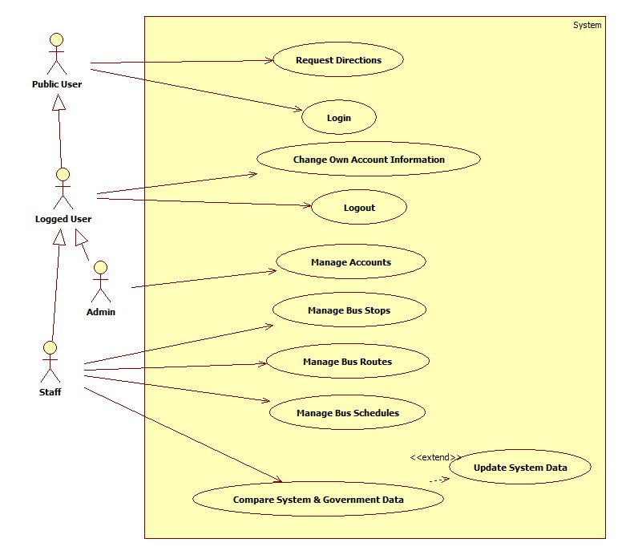

Figure 2: System Features Overview

### Public User

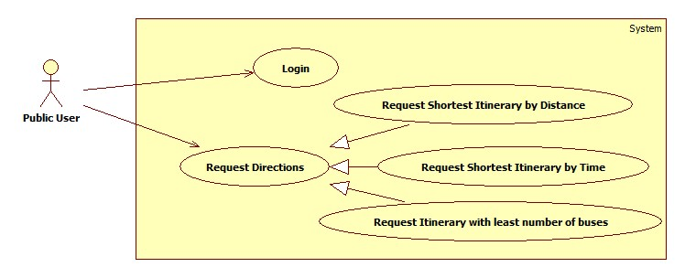

Figure 3: Public User Features

#### Login

|  |  |  |  |  |
| --- | --- | --- | --- | --- |
| USE CASE–PU001 | | | | |
| Use-case No. | PU001 | Use-case Version | | 0.1 |
| Use-case Name | Login | | | |
| Author | Nguyen Viet Vinh | | | |
| Date | 23/01/2013 | Priority | High | |
| **Actor:** Public User  **Summary:** This use case allows administrator, staff to log on into the system  **Goal:** Authenticate user.  **Triggers:** User access website area that is intended for staff and administrator.  **Pre-conditions:** User has an account and has not logged in yet  **Post-conditions.**  **Success:** User has logged in  Redirects to Staff or Admin page  **Fail:** Redirects to Public page  **Main Success Scenario.**   |  |  |  | | --- | --- | --- | | Step | Actor Action | System Response | | 1 | User enter Staff or Admin area of the website | Display the form to login includes:   * Username: textbox. * Password: password field. * Remember: checkbox * Login: button * Reset: button | | 2 | User fills username and password |  | | 3 | User click “Login” button [Alternative 1] [Exception 1]. | Check for account validity and  Redirect to Synchronize Page for Staff or Account Management page for Admin if user’s credential is valid. [Alternative 2]  If user selects “Remember”, put a cookie on client browser. |   **Alternative Scenario.**   |  |  |  | | --- | --- | --- | | No. | Actor Action | System Response | | 1 | User click “Reset” | Clear username and password textbox. | | 2 | User credential is not valid | Display error message “The username or password you entered is incorrect”. |   **Exceptions**.   |  |  |  | | --- | --- | --- | | No. | Actor Action | System Response | | 1 | User leaves username textbox empty. | Display error message “username cannot be empty”. |   Relationships: N/A  Business Rules: N/A | | | | |

Table 2: Use Case PU001 - Login

#### Request Directions

##### Shortest itinerary in term of time

|  |  |  |  |  |
| --- | --- | --- | --- | --- |
| USE CASE–PU002 | | | | |
| Use-case No. | PU002 | Use-case Version | | 0.1 |
| Use-case Name | Request Shortest Itinerary by Time | | | |
| Author | Nguyen Viet Vinh | | | |
| Date | 23/01/2013 | Priority | High | |
| **Actor:** Public User  **Summary:** This use case allows user to find the best bus routes for destinations in term of time.  **Goal:** User’s able to get the itinerary of bus routes, from the start point to the end point.  **Triggers:** User enter public service page.  **Pre-conditions:** None  **Post-conditions:**  **Success:** Display the most suitable itineraries.  **Fail:** Display message “No suitable itineraries found”.  **Main Success Scenario.**   |  |  |  | | --- | --- | --- | | Step | Actor Action | System Response | | 1 | User enters public page | Show Public page includes:   * A map centered at user location [Exception 1]. * Departure Address: textbox. * Destination Address: textbox. * Departure Time: radio button. * Arrival Time: radio button. * Time: Time Picker (min: 4:00, max 22:00). * Maximum distance between walking transits: number (min: 0, max 1000) | | 1 | User enters address of departure in departure text box [Alternative 1]. | Show departure location on map [Exception 2]. | | 2 | User enters address of destination in destination text box [Alternative 2]. | Show destination location on map [Exception 2]. | | 3 | User enters time, walking transits, select arrival or departure time. |  | | 4 | Click “Nhanh nhất” [Alternative 3, 4] | Show the found bus route’s itinerary on map and directions [Exception 3]. |   **Alternative Scenario.**   |  |  |  | | --- | --- | --- | | No. | Actor Action | System Response | | 1 | User point out departure location on map. | Show departure address in departure text box [Exception 2]. | | 2 | User point out destination location on map. | Show destination address in destination text box [Exception 2]. |   **Exceptions**.   |  |  |  | | --- | --- | --- | | No. | Actor Action | System Response | | 1 | Cannot get user location due to device capability or user privacy | The map is centered at Main City Bus Station. | | 2 | Departure or Destination is outside of HCM City | Display Error Message “The system cannot provide directions outside of HCM city”. | | 3 | The System cannot found any result based on user criteria. | Display Error Message “No suitable itinerary found”. |   Relationships: None  Business Rules: Google Map API | | | | |

Table 3: Use Case PU002 - Request Shortest Itinerary in term of time

##### Shortest itinerary in term of distance

|  |  |  |  |  |
| --- | --- | --- | --- | --- |
| USE CASE–PU003 | | | | |
| Use-case No. | PU003 | Use-case Version | | 0.1 |
| Use-case Name | Request Itinerary by Distance | | | |
| Author | Nguyen Viet Vinh | | | |
| Date | 23/01/2013 | Priority | High | |
| **Actor:** Public User  **Summary:** This use case allows user to find the best bus routes for destinations in term of distance.  **Goal:** User’s able to get the itinerary of bus routes, from the start point to the end point.  **Triggers:** User enter public service page.  **Pre-conditions:** None  **Post-conditions:**  **Success:** Display the most suitable itineraries.  **Fail:** Display message “No suitable itineraries found”.  **Main Success Scenario.**   |  |  |  | | --- | --- | --- | | Step | Actor Action | System Response | | 1 | User enters public page | Show Public page includes:   * A map centered at user location [Exception 1]. * Departure Address: textbox. * Destination Address: textbox. * Departure Time: radio button. * Arrival Time: radio button. * Time: Time Picker (min: 4:00, max 22:00). * Distance between walking transits: number (min: 0, max 1000) | | 1 | User enters address of departure in departure text box [Alternative 1]. | Show departure location on map [Exception 2]. | | 2 | User enters address of destination in destination text box [Alternative 2]. | Show destination location on map [Exception 2]. | | 3 | User enters time, walking transits, select arrival or departure time. |  | | 4 | Click “Ngắn nhất” [Alternative 3, 4] | Show the found bus route’s itinerary on map and directions [Exception 3]. |   **Alternative Scenario.**   |  |  |  | | --- | --- | --- | | No. | Actor Action | System Response | | 1 | User point out departure location on map. | Show departure address in departure text box [Exception 2]. | | 2 | User point out destination location on map. | Show destination address in destination text box [Exception 2]. |   **Exceptions**.   |  |  |  | | --- | --- | --- | | No. | Actor Action | System Response | | 1 | Cannot get user location due to device capability or user privacy | The map is centered at Main City Bus Station. | | 2 | Departure or Destination is outside of HCM City | Display Error Message “The system cannot provide directions outside of HCM city”. | | 3 | The System cannot found any result based on user criteria. | Display Error Message “No suitable itinerary found”. |   Relationships: None  Business Rules: None | | | | |

Table 4: Use Case PU003 - Request Shortest Itinerary in term of distance

##### Itinerary with least number of buses

|  |  |  |  |  |
| --- | --- | --- | --- | --- |
| USE CASE–PU004 | | | | |
| Use-case No. | PU004 | Use-case Version | | 0.1 |
| Use-case Name | Itinerary with least number of buses | | | |
| Author | Nguyen Viet Vinh | | | |
| Date | 23/01/2013 | Priority | High | |
| **Actor:** Public User  **Summary:** This use case allows user to find the best bus routes for destinations using least number of buses.  **Goal:** User’s able to get the itinerary of bus routes, from the start point to the end point.  **Triggers:** User enter public service page.  **Pre-conditions:** None  **Post-conditions:**  **Success:** Display the most suitable itineraries.  **Fail:** Display message “No suitable itineraries found”.  **Main Success Scenario.**   |  |  |  | | --- | --- | --- | | Step | Actor Action | System Response | | 1 | User enters public page | Show Public page includes:   * A map centered at user location [Exception 1]. * Departure Address: textbox. * Destination Address: textbox. * Departure Time: radio button. * Arrival Time: radio button. * Time: Time Picker (min: 4:00, max 22:00). * Distance between walking transits: number (min: 0, max 1000) | | 1 | User enters address of departure in departure text box [Alternative 1]. | Show departure location on map [Exception 2]. | | 2 | User enters address of destination in destination text box [Alternative 2]. | Show destination location on map [Exception 2]. | | 3 | User enters time, walking transits, select arrival or departure time. |  | | 4 | Click “Ít buýt nhất” [Alternative 3, 4] | Show the found bus route’s itinerary on map and directions [Exception 3]. |   **Alternative Scenario.**   |  |  |  | | --- | --- | --- | | No. | Actor Action | System Response | | 1 | User point out departure location on map. | Show departure address in departure text box [Exception 2]. | | 2 | User point out destination location on map. | Show destination address in destination text box [Exception 2]. |   **Exceptions**.   |  |  |  | | --- | --- | --- | | No. | Actor Action | System Response | | 1 | Cannot get user location due to device capability or user privacy | The map is centered at Main City Bus Station. | | 2 | Departure or Destination is outside of HCM City | Display Error Message “The system cannot provide directions outside of HCM city”. | | 3 | The System cannot found any result based on user criteria. | Display Error Message “No suitable itinerary found”. |   Relationships: None  Business Rules: None | | | | |

Table 5: Use Case PU004 - Request Itinerary with least number of buses

### Logged Users

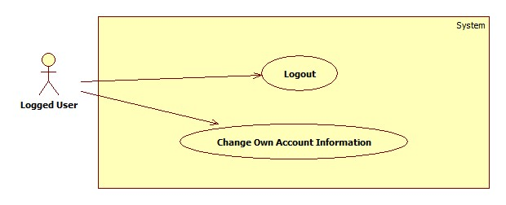

Figure 4: Logged Users Features

#### Logout

#### Change Own Account Information

|  |  |  |  |  |
| --- | --- | --- | --- | --- |
| USE CASE–LU002 | | | | |
| Use-case No. | LU002 | Use-case Version | | 0.1 |
| Use-case Name | Edit an Account Information | | | |
| Author | Nguyen Viet Vinh | | | |
| Date | 23/01/2013 | Priority | High | |
| **Actor:** Logged User  **Summary:** This use case allows user to edit his or her account information  **Goal:** Change information of his or her account.  **Triggers:** User clicks “Edit Information” on navigation bar.  **Pre-conditions:** User has logged in as an administrator or staff.  **Post-conditions:**  **Success:** The information of his or her account is updated.  **Fail:** The information of his or her account is not updated. Display error message.  **Main Success Scenario.**   |  |  |  | | --- | --- | --- | | Step | Actor Action | System Response | | 1 | User clicks “Edit Information” on navigation bar. | Display account information page includes:   * Username: label. * Password: password field (min length: 6, max length: 30) * Full name: textbox (min length: 1, max length: 50) * Email: textbox (regular expression) * Date of birth: Date Picker. * Telephone: textbox (regular expression) * Is Admin: disabled checkbox. * Is Staff: disabled checkbox [Alternative 1]. * Save: button * Reset: button | | 2 | User modifies account information |  | | 3 | Click “Save” [Alternative 1, 2] | Valid entered information and update account information. |   **Alternative Scenario.**   |  |  |  | | --- | --- | --- | | No. | Actor Action | System Response | | 1 | User is admin | Is Staff: check box. | | 2 | User clicks “Reset” | Refresh the all input controls with original values. | | 3 | User clicks “Reset Password” | Generate a new password for that account, update account password and send it to his or her email |   **Exceptions**.   |  |  |  | | --- | --- | --- | | Step | Actor Action | System Response | | 1 | User is admin and he/she set himself/herself not an admin | Display an error message “You cannot set yourself as non-admin”. |   Relationships: None  Business Rules: None | | | | |

Table 6: Use Case LU002 - Change Own Account Information

### Admin

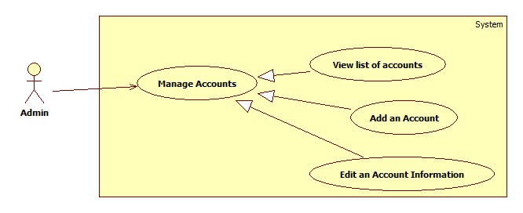

Figure 5: Admin Features

#### View List of Accounts

|  |  |  |  |  |
| --- | --- | --- | --- | --- |
| USE CASE–AD001 | | | | |
| Use-case No. | AD001 | Use-case Version | | 0.1 |
| Use-case Name | View List of Accounts | | | |
| Author | Nguyen Viet Vinh | | | |
| Date | 23/01/2013 | Priority | High | |
| **Actor:** Administrator  **Summary:** This use case allows administrator to view the list of accounts in system.  **Goal:** List of accounts in system is displayed.  **Triggers:** Administrator access Account Management Page.  **Pre-conditions:** User has logged in as an administrator.  **Post-conditions:**  **Success:** List of accounts in system is displayed.  **Fail:** Redirect to General Error Page.  **Main Success Scenario.**   |  |  |  | | --- | --- | --- | | Step | Actor Action | System Response | | 1 | Enter the Account Management page | Display the list of accounts in system and their information includes:   * Add new account: button * A table with these column   + Username: label   + Full name: label   + Email: label   + Date of birth: label   + Telephone: label   + Is Admin: disabled checkbox.   + Is Staff: disabled checkbox   + Status: label   + Edit: button |   **Alternative Scenario.**  N/A  **Exceptions**.  N/A  Relationships: None  Business Rules: None | | | | |

Table 7: Use Case AD001 - View List of Accounts

#### Add an Account

|  |  |  |  |  |
| --- | --- | --- | --- | --- |
| USE CASE-AD002 | | | | |
| Use-case No. | AD002 | Use-case Version | | 0.1 |
| Use-case Name | Add an Account | | | |
| Author | Nguyen Viet Vinh | | | |
| Date | 23/01/2013 | Priority | High | |
| **Actor:** Administrator  **Summary:** This use case allows administrator to add a new account in system.  **Goal:** Create a new account.  **Triggers:** Administrator click “Add New Account” in Account Management Page.  **Pre-conditions:** User has logged in as an administrator.  **Post-conditions:**  **Success:** A new account has been created in system.  **Fail:** None of account is added to the system. Display error message.  **Main Success Scenario.**   |  |  |  | | --- | --- | --- | | Step | Actor Action | System Response | | 1 | Admin clicks “Add New Account” in Account Management Page. | Display account information page includes:   * Username: textbox (min length: 4, max length: 30) * Full name: textbox (min length: 3, max length: 50) * Email: textbox (regular expression) * Date of birth: Date Picker (min: current year – 60, max: current year – 18) * Telephone: textbox (regular expression) * Is Admin: checkbox. * Is Staff: checkbox * Add: button * Reset: button | | 2 | Admin enters account information |  | | 3 | Admin clicks “Add” [Alternative 1] | Valid entered information and create a new account with entered information [Exception 1, 2, 3]. |   **Alternative Scenario.**   |  |  |  | | --- | --- | --- | | No. | Actor Action | System Response | | 1 | Admin clicks “Reset” | Clear all input controls on form. |   **Exceptions**.   |  |  |  | | --- | --- | --- | | No. | Actor Action | System Response | | 1 | Username contain whitespaces | Display an error message “Username cannot contain white space”. | | 2 | Username is already in the system. | Display an error message “Username is already in the system, please choose another one”. | | 3 | Both IsAdmin and IsStaff is unchecked | Display an error message “An account must have at least one role in system”. |   Relationships: None  Business Rules: None | | | | |

Table 8: Use Case AD002 - Add an Account

#### Edit an Account Information

|  |  |  |  |  |
| --- | --- | --- | --- | --- |
| USE CASE–AD003 | | | | |
| Use-case No. | AD003 | Use-case Version | | 0.1 |
| Use-case Name | Edit an Account Information | | | |
| Author | Nguyen Viet Vinh | | | |
| Date | 23/01/2013 | Priority | High | |
| **Actor:** Administrator  **Summary:** This use case allows administrator to edit an account information  **Goal:** Change information of an existing account.  **Triggers:** Administrator click “Edit” associated with an account in Account Management Page.  **Pre-conditions:** User has logged in as an administrator.  **Post-conditions:**  **Success:** The information of edited account is updated.  **Fail:** The information of edited account is not updated. Display error message.  **Main Success Scenario.**   |  |  |  | | --- | --- | --- | | Step | Actor Action | System Response | | 1 | Click “Edit” associated with an account in Account Management page. | Display account information page includes:   * Username: disabled textbox * Full name: textbox (min length: 3, max length: 50) * Email: textbox (regular expression) * Date of birth: Date Picker. * Telephone: textbox (regular expression) * Is Admin: checkbox. * Is Staff: checkbox. * Is Active: checkbox. * Reset Password: button * Save: button * Cancel: button | | 2 | Admin modify account information |  | | 3 | Click “Save” [Alternative 1, 2] | Valid entered information and update account information [Exception 1, 2]. |   **Alternative Scenario.**   |  |  |  | | --- | --- | --- | | No. | Actor Action | System Response | | 1 | Admin clicks “Cancel” | Redirect to Account Management Page. | | 2 | Admin clicks “Reset Password” | Generate a new password for that account, update account password and send it to his or her email |   **Exceptions**.   |  |  |  | | --- | --- | --- | | Step | Actor Action | System Response | | 1 | Admin set himself/herself not an admin | Display an error message “You cannot set yourself as non-admin”. | | 2 | Both IsAdmin and IsStaff is unchecked and IsActive is checked. | Display an error message “An account must have at least one role in system”. |   Relationships: None  Business Rules: None | | | | |

Table 9: Use Case AD003 - Edit an Account Information

### Staff

#### Compare Local and Government Data

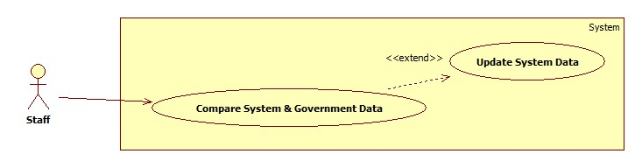

Figure 6: Synchronize Data

##### Compare Local & Government Data

|  |  |  |  |  |
| --- | --- | --- | --- | --- |
| USE CASE–ST001 | | | | |
| Use-case No. | ST001 | Use-case Version | | 0.1 |
| Use-case Name | Compare System & Government Data | | | |
| Author | Nguyen Viet Vinh | | | |
| Date | 23/01/2013 | Priority | High | |
| **Actor:** Staff  **Summary:** This use case allows staff to view the differences between system and government bus routes data.  **Goal:** Show differences between system and government bus routes data.  **Triggers:** Staff access “Synchronizer” page.  **Pre-conditions:** User has logged in as a staff.  **Post-conditions.** List of differences is displayed.  **Main Success Scenario.**   |  |  |  | | --- | --- | --- | | Step | Actor Action | System Response | | 1 | Staff access Synchronizer page. | Display list of bus routes that system and government data differ includes [Exception 1]:   * A table with these columns:   + No: label   + Code: label + image   + Name: label   + Change: label   + Sync: checkbox * Synchronize: button * A map. | | 2 | Click on a difference (a row in the table of changes) | Draw 2 bus routes on map:   * One from system data. * One from government data. |   **Alternative Scenario.**  N/A  **Exceptions**.   |  |  |  | | --- | --- | --- | | Step | Actor Action | System Response | | 1 | Cannot access government data. | Display an error message “Government data is not available at this time”. | | 2 | Government Data Structure changed |  |   Relationships: Update System Data.  Business Rules: None | | | | |

Table 10: Use Case ST001 - Compare Local & Government Data

##### Update System Data

|  |  |  |  |  |
| --- | --- | --- | --- | --- |
| USE CASE–ST002 | | | | |
| Use-case No. | ST002 | Use-case Version | | 0.1 |
| Use-case Name | Update System Data. | | | |
| Author | Nguyen Viet Vinh | | | |
| Date | 23/01/2013 | Priority | High | |
| **Actor:** Staff  **Summary:** This use case allows staff to update system data from government data.  **Goal:** System data is updated from government data.  **Triggers:** Staff click “Synchronize” button displayed in “Synchronizer” page.  **Pre-conditions:** User has logged in as a staff.  **Post-conditions.** System routes data is updated.  **Main Success Scenario.**   |  |  |  | | --- | --- | --- | | Step | Actor Action | System Response | | 1 | Staff access Synchronizer page. | Display list of bus routes that system and government data differ includes [Exception 1]:   * A table with these columns:   + No: label   + Code: label + image   + Name: label   + Change: label   + Sync: checkbox * Synchronize: button * A map. | | 2 | User checks on which bus routes to update. |  | | 3 | User click “Synchronize” button | Update system bus routes data of selected routes. |   **Alternative Scenario.**  N/A  **Exceptions**.   |  |  |  | | --- | --- | --- | | Step | Actor Action | System Response | | 1 | Cannot access government data. | Display an error message “Government data is not available at this time”. |   Relationships: None  Business Rules: None | | | | |

Table 11: Use Case ST002 - Update System Data

#### Manage Bus Stops

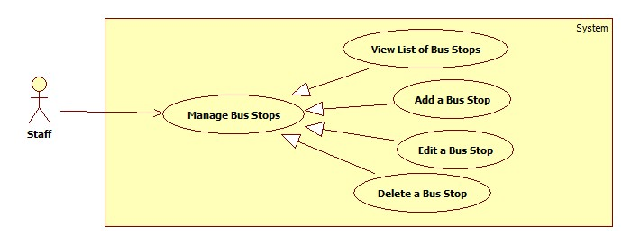

Figure 7: Manage Bus Stops

##### View list of Bus Stops

|  |  |  |  |  |
| --- | --- | --- | --- | --- |
| USE CASE–ST003 | | | | |
| Use-case No. | ST003 | Use-case Version | | 0.1 |
| Use-case Name | View List of Bus Stops | | | |
| Author | Nguyen Viet Vinh | | | |
| Date | 23/01/2013 | Priority | High | |
| **Actor:** Staff  **Summary:** This use case allows staff to view the list of bus stops.  **Goal:** List of bus stops in system is displayed.  **Triggers:** Staff access Bus Stops Management Page.  **Pre-conditions:** User has logged in as a staff.  **Post-conditions:**  **Success:** List of bus stops in system is displayed.  **Fail:** Redirect to General Error Page.  **Main Success Scenario.**   |  |  |  | | --- | --- | --- | | Step | Actor Action | System Response | | 1 | Enter the Bus Stops Management page | Display the list of bus stops in system and their information includes:   * Add new bus stop: button * A table with these column   + No: label   + Code: label   + Name: label   + Street: label   + Ward: label   + Edit: button   + Delete: button * A Map to display bus stops location |   **Alternative Scenario.**  N/A  **Exceptions**.  N/A  Relationships: None  Business Rules: None | | | | |

Table 12: Use Case ST003 - View list of Bus Stops

##### Add a new Bus Stop

|  |  |  |  |  |
| --- | --- | --- | --- | --- |
| USE CASE-ST004 | | | | |
| Use-case No. | ST004 | Use-case Version | | 0.1 |
| Use-case Name | Add a new Bus Stop | | | |
| Author | Nguyen Viet Vinh | | | |
| Date | 23/01/2013 | Priority | High | |
| **Actor:** Staff  **Summary:** This use case allows staff to add a new bus stop into system.  **Goal:** Create a new bus stop.  **Triggers:** Staff clicks “Add New Bus Stop” in Account Management Page.  **Pre-conditions:** User has logged in as a staff.  **Post-conditions:**  **Success:** A new bus stop has been created in system.  **Fail:** None of bus stop is added to the system. Display error message.  **Main Success Scenario.**   |  |  |  | | --- | --- | --- | | Step | Actor Action | System Response | | 1 | Staff clicks “Add New Bus Stop” in Bus Stop Management Page. | Display bus stop information page includes:   * Address: textbox * Latitude: number (min: -180.0, max 180.0) * Longitude: number (min: -180.0, max: 180.0) * Add: button * Cancel: button * A map to show bus stop location | | 2 | Staff enters bus stop address [Alternative 1, 2] | * Display bus stop on map. * Show latitude, longitude of new bus stop. | | 3 | Staff clicks “Add” [Alternative 3] | Valid entered information and create a new bus stop with entered information and generated bus stop code [Exception 1]. |   **Alternative Scenario.**   |  |  |  | | --- | --- | --- | | No. | Actor Action | System Response | | 1 | Staff enter Latitude, Longitude | Display bus stop address in Address textbox and show location on map. | | 2 | Staff show bus stop location on map | Display bus stop address in Address textbox, latitude and longitude in Latitude and Longitude inputs. | | 3 | Staff clicks “Cancel” | Redirect to Bus Stop Management page. |   **Exceptions**.   |  |  |  | | --- | --- | --- | | No. | Actor Action | System Response | | 1 | Within the sphere of 10m, there are one or more bus stops near the newly built bus stop. | Display an error message “Duplicate bus stop”. |   Relationships: None  Business Rules: Google Map API | | | | |

Table 13: Use Case ST004 - Add a new Bus Stop

##### Edit a Bus Stop

|  |  |  |  |  |
| --- | --- | --- | --- | --- |
| USE CASE–ST005 | | | | |
| Use-case No. | ST005 | Use-case Version | | 0.1 |
| Use-case Name | Edit a Bus Stop | | | |
| Author | Nguyen Viet Vinh | | | |
| Date | 23/01/2013 | Priority | High | |
| **Actor:** Staff  **Summary:** This use case allows staff to update information of a bus stop.  **Goal:** Change information of an existing bus stop.  **Triggers:** Staff clicks “Edit” associated with a bus stop in Bus Stop Management Page.  **Pre-conditions:** User has logged in as a staff.  **Post-conditions:**  **Success:** The information of edited bus stop is updated.  **Fail:** The information of edited bus stop is not updated. Display error message.  **Main Success Scenario.**   |  |  |  | | --- | --- | --- | | Step | Actor Action | System Response | | 1 | Click “Edit” associated with a bus stop in Bus Stop Management page. | Display bus stop information page includes:   * Code: disabled textbox * Address: textbox * Latitude: number (min: -180.0, max 180.0) * Longitude: number (min: -180.0, max: 180.0) * Save: button * Cancel: button * A map to show bus stop location | | 2 | Staff modify account information |  | | 3 | Click “Cancel” [Alternative 1] | Valid entered information and update account information [Exception 1, 2]. |   **Alternative Scenario.**   |  |  |  | | --- | --- | --- | | No. | Actor Action | System Response | | 1 | Staff clicks “Cancel” | Redirect to Bus Stop Management page. |   **Exceptions**.   |  |  |  | | --- | --- | --- | | No. | Actor Action | System Response | | 1 | Within the sphere of 10m, there are one or more bus stops near the newly built bus stop. | Display an error message “Duplicate bus stop”. |   Relationships: None  Business Rules: None | | | | |

Table 14: Use Case ST005 - Edit a Bus Stop

##### Delete a Bus Stop

|  |  |  |  |  |
| --- | --- | --- | --- | --- |
| USE CASE–ST006 | | | | |
| Use-case No. | ST006 | Use-case Version | | 0.1 |
| Use-case Name | Delete a Bus Stop | | | |
| Author | Nguyen Viet Vinh | | | |
| Date | 23/01/2013 | Priority | High | |
| **Actor:** Staff  **Summary:** This use case allows staff to delete a bus stop.  **Goal:** Remove a bus stop out of the system.  **Triggers:** Staff clicks “Delete” associated with a bus stop in Bus Stop Management Page.  **Pre-conditions:** User has logged in as a staff.  **Post-conditions:**  **Success:** The information of selected bus stop is deleted.  **Fail:** None of bus stop is deleted. Display error message.  **Main Success Scenario.**   |  |  |  | | --- | --- | --- | | Step | Actor Action | System Response | | 1 | Click “Delete” associated with a bus stop in Bus Stop Management page. | Display a confirm message. | | 2 | Click “Yes” [Alternative 1] | Remove the selected bus stop out of the system [Exception 1]. |   **Alternative Scenario.**   |  |  |  | | --- | --- | --- | | No. | Actor Action | System Response | | 1 | Staff clicks “Cancel” | Redirect to Bus Stop Management page. |   **Exceptions**.   |  |  |  | | --- | --- | --- | | No. | Actor Action | System Response | | 1 | The selected bus stop belongs to one or more bus routes. | Display an error message “Cannot delete the selected bus stop because it is in use”. |   Relationships: None  Business Rules: None | | | | |

Table 15: Use Case ST006 - Delete a Bus Stop

#### Manage Bus Routes

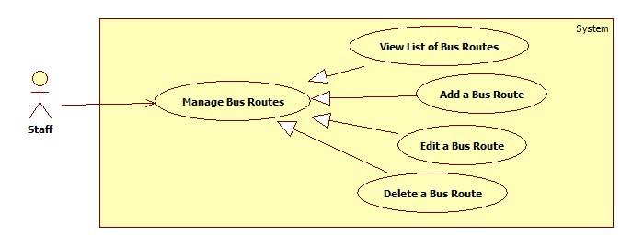

Figure 8: Manage Bus Routes

##### View list of Bus Routes

|  |  |  |  |  |
| --- | --- | --- | --- | --- |
| USE CASE–ST007 | | | | |
| Use-case No. | ST007 | Use-case Version | | 0.1 |
| Use-case Name | View List of Bus Routes | | | |
| Author | Nguyen Viet Vinh | | | |
| Date | 23/01/2013 | Priority | High | |
| **Actor:** Staff  **Summary:** This use case allows staff to view the list of bus routes.  **Goal:** List of bus routes in system is displayed.  **Triggers:** Staff access Bus Routes Management Page.  **Pre-conditions:** User has logged in as a staff.  **Post-conditions:**  **Success:** List of bus routes in system is displayed.  **Fail:** Redirect to General Error Page.  **Main Success Scenario.**   |  |  |  | | --- | --- | --- | | Step | Actor Action | System Response | | 1 | Enter the Bus Routes Management page | Display the list of bus routes in system and their information includes:   * Add new bus route: button * A table with these column   + No: label   + Code: label   + Name: label   + Outward: label   + Edit: button   + Delete: button * A Map to display bus route. |   **Alternative Scenario.**  N/A  **Exceptions**.  N/A  Relationships: None  Business Rules: None | | | | |

Table 16: Use Case ST007 - View list of Bus Routes

##### Add a new Bus Route

|  |  |  |  |  |
| --- | --- | --- | --- | --- |
| USE CASE-ST008 | | | | |
| Use-case No. | ST008 | Use-case Version | | 0.1 |
| Use-case Name | Add a new Bus Route | | | |
| Author | Nguyen Viet Vinh | | | |
| Date | 23/01/2013 | Priority | High | |
| **Actor:** Staff  **Summary:** This use case allows staff to add a new bus route into system.  **Goal:** Create a new bus route.  **Triggers:** Staff clicks “Add New Bus Route” in Account Management Page.  **Pre-conditions:** User has logged in as a staff.  **Post-conditions:**  **Success:** A new bus route has been created in system.  **Fail:** None of bus route is added to the system. Display error message.  **Main Success Scenario.**   |  |  |  | | --- | --- | --- | | Step | Actor Action | System Response | | 1 | Staff clicks “Add New Bus Route” in Bus Route Management Page. | Display bus route information page includes:   * Code: textbox (min length: 1, max length: 10) * Name: textbox (min length: 10, max length: 100) * Outward: checkbox * List of stops: table. * Available bus stop: combo box * Add bus stop: button * Move up: button * Move down: button * Remove bus stop: button * Add: button * Cancel: button * A map to show bus route | | 2 | Staff enters bus route information |  | | 3 | Staff edit list of stop of the route | * Update route on map. | | 3 | Staff clicks “Add” [Alternative 1] | Valid entered information and create a new bus route with entered information [Exception 1]. |   **Alternative Scenario.**   |  |  |  | | --- | --- | --- | | No. | Actor Action | System Response | | 1 | Staff clicks “Cancel” | Redirect to Bus Route Management page. |   **Exceptions**.   |  |  |  | | --- | --- | --- | | No. | Actor Action | System Response | | 1 | There is another bus route with the same value of code and outward. | Display an error message “Duplicate bus route”. |   Relationships: None  Business Rules: None | | | | |

Table 17: Use Case ST008 - Add a new Bus Route

##### Edit a Bus Route

|  |  |  |  |  |
| --- | --- | --- | --- | --- |
| USE CASE-ST009 | | | | |
| Use-case No. | ST009 | Use-case Version | | 0.1 |
| Use-case Name | Edit a Bus Route | | | |
| Author | Nguyen Viet Vinh | | | |
| Date | 23/01/2013 | Priority | High | |
| **Actor:** Staff  **Summary:** This use case allows staff to edit a bus route in system.  **Goal:** Update information of a bus route.  **Triggers:** Click “Edit” associated with a bus stop in Bus Route Management page.  **Pre-conditions:** User has logged in as a staff.  **Post-conditions:**  **Success:** The information of edited bus route is updated.  **Fail:** The information of edited bus route is not updated. Display error message.  **Main Success Scenario.**   |  |  |  | | --- | --- | --- | | Step | Actor Action | System Response | | 1 | Click “Edit” associated with a bus stop in Bus Route Management page. | Display bus route information page includes:   * Code: disabled textbox * Name: textbox (max length: 100) * Outward: checkbox * List of stops: table. * Available bus stop: combo box * Add bus stop: button * Move up: button * Move down: button * Remove bus stop: button * Save: button * Cancel: button * A map to show bus route | | 2 | Staff modify bus route information |  | | 3 | Staff edit list of stop of the route | * Update route on map. | | 3 | Staff clicks “Save” [Alternative 1] | Valid entered information and update information of the bus [Exception 1]. |   **Alternative Scenario.**   |  |  |  | | --- | --- | --- | | No. | Actor Action | System Response | | 1 | Staff clicks “Cancel” | Redirect to Bus Route Management page. |   **Exceptions**.   |  |  |  | | --- | --- | --- | | No. | Actor Action | System Response | | 1 | There is another bus route with the same value of code and outward. | Display an error message “Duplicate bus route”. |   Relationships: None  Business Rules: None | | | | |

Table 18: Use Case ST009 - Edit a Bus Route

##### Delete a Bus Route

|  |  |  |  |  |
| --- | --- | --- | --- | --- |
| USE CASE–ST010 | | | | |
| Use-case No. | ST010 | Use-case Version | | 0.1 |
| Use-case Name | Delete a Bus Route | | | |
| Author | Nguyen Viet Vinh | | | |
| Date | 23/01/2013 | Priority | High | |
| **Actor:** Staff  **Summary:** This use case allows staff to delete a bus route.  **Goal:** Remove a bus route out of the system.  **Triggers:** Staff clicks “Delete” associated with a bus route in Bus Route Management Page.  **Pre-conditions:** User has logged in as a staff.  **Post-conditions:**  **Success:** The information of selected bus route is deleted.  **Fail:** None of bus route is deleted. Display error message.  **Main Success Scenario.**   |  |  |  | | --- | --- | --- | | Step | Actor Action | System Response | | 1 | Click “Delete” associated with a bus route in Bus Route Management page. | Display a confirm message. | | 2 | Click “Yes” [Alternative 1] | Remove the selected bus route out of the system and its associated schedule. |   **Alternative Scenario.**   |  |  |  | | --- | --- | --- | | No. | Actor Action | System Response | | 1 | Staff clicks “Cancel” | Redirect to Bus Route Management page. |   **Exceptions**.  N/A  Relationships: None  Business Rules: None | | | | |

Table 19: Use Case ST010 - Delete a Bus Route

#### Manage Bus Schedules

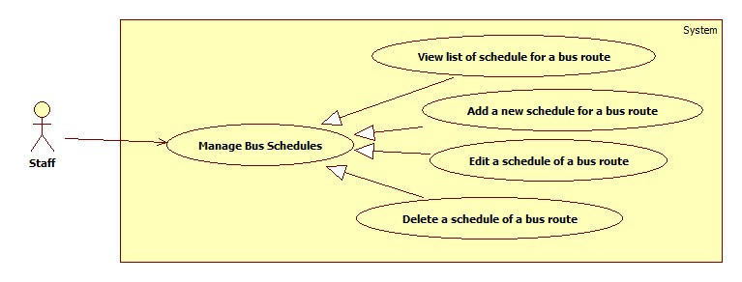

Figure 9: Manage Bus Schedules

##### View list of Schedule for a Bus Route

|  |  |  |  |  |
| --- | --- | --- | --- | --- |
| USE CASE–ST011 | | | | |
| Use-case No. | ST011 | Use-case Version | | 0.1 |
| Use-case Name | View List of Schedules for a bus route | | | |
| Author | Nguyen Viet Vinh | | | |
| Date | 23/01/2013 | Priority | High | |
| **Actor:** Staff  **Summary:** This use case allows staff to view the list of schedules for a bus route.  **Goal:** List of schedules for a bus route in system is displayed.  **Triggers:** Staff access Schedule Management Page.  **Pre-conditions:** User has logged in as a staff.  **Post-conditions:**  **Success:** List of schedule for a bus route in system is displayed.  **Fail:** Redirect to General Error Page.  **Main Success Scenario.**   |  |  |  | | --- | --- | --- | | Step | Actor Action | System Response | | 1 | Enter the Schedule Management page | * Display the list of bus route with these information:   + Code   + Name   + Outward | | 2 | Staff choose a bus route from the list | * Display the list of week days. * A Date picker. | | 3 | Staff chooses a week day or select specific date from Data picker. | * Display the list of departure time of selected bus route in selected date. |   **Alternative Scenario.**  N/A  **Exceptions**.  N/A  Relationships: None  Business Rules: None | | | | |

Table 20: Use Case ST011 - View list of Schedule for a Bus Route

##### Add a new Schedule for a Bus Route

|  |  |  |  |  |
| --- | --- | --- | --- | --- |
| USE CASE–ST012 | | | | |
| Use-case No. | ST012 | Use-case Version | | 0.1 |
| Use-case Name | Add a new schedule for a bus route | | | |
| Author | Nguyen Viet Vinh | | | |
| Date | 23/01/2013 | Priority | High | |
| **Actor:** Staff  **Summary:** This use case allows staff to add a new schedule for a bus route.  **Goal:** Add a new schedule for a bus route.  **Triggers:** Staff access Schedule Management Page and click “Add” in the schedule list.  **Pre-conditions:** User has logged in as a staff.  **Post-conditions:**  **Success:** A new schedule is added for a bus route.  **Fail:** None of schedule is added. Display error message.  **Main Success Scenario.**   |  |  |  | | --- | --- | --- | | Step | Actor Action | System Response | | 1 | Enter the Schedule Management page | * Display the list of bus route with these information:   + Code   + Name   + Outward | | 2 | Staff choose a bus route from the list | * Display the list of week days. * A Date picker (min, max, default). | | 3 | Staff chooses a week day or select specific date from Data picker. | * Display the list of departure time of selected bus route in selected date. | | 4 | Click “Add Schedule” button | * Display a dialog:   + Departure time: time picker (min: 4:00, max 22:00).   + Add: button   + Cancel: button | | 5 | Staff selects departure time and clicks “Add” [Alternative 1] | * Valid information and add a new schedule for the selected bus route in selected date [Exception 1]. |   **Alternative Scenario.**   |  |  |  | | --- | --- | --- | | No. | Actor Action | System Response | | 1 | Staff clicks “Cancel” | Dialog disappears without any affect. |   **Exceptions**.   |  |  |  | | --- | --- | --- | | No. | Actor Action | System Response | | 1 | There is an existing schedule with the same time in the same date for the same bus route. | Display error message “The departure time already exists”. |   Relationships: None  Business Rules: None | | | | |

Table 21: Add a new Schedule for a Bus Route

##### Edit a Schedule of a Bus Route

|  |  |  |  |  |
| --- | --- | --- | --- | --- |
| USE CASE–ST013 | | | | |
| Use-case No. | ST013 | Use-case Version | | 0.1 |
| Use-case Name | Edit a schedule for a bus route | | | |
| Author | Nguyen Viet Vinh | | | |
| Date | 23/01/2013 | Priority | High | |
| **Actor:** Staff  **Summary:** This use case allows staff to edit a schedule of a bus route.  **Goal:** Update a schedule of a bus route.  **Triggers:** Staff access Schedule Management Page and double click on a schedule in the list.  **Pre-conditions:** User has logged in as a staff.  **Post-conditions:**  **Success:** The edited schedule is update for the bus route.  **Fail:** None of schedule is updated. Display error message.  **Main Success Scenario.**   |  |  |  | | --- | --- | --- | | Step | Actor Action | System Response | | 1 | Enter the Schedule Management page | * Display the list of bus route with these information:   + Code   + Name   + Outward | | 2 | Staff choose a bus route from the list | * Display the list of week days. * A Date picker. | | 3 | Staff chooses a week day or select specific date from Data picker. | * Display the list of departure time of selected bus route in selected date. | | 4 | Double click on a schedule in the list | * Display a dialog:   + Departure time: time picker.   + Save: button   + Cancel: button | | 5 | Staff selects departure time and clicks “Save” [Alternative 1] | * Valid information and add update the schedule for the selected bus route in selected date [Exception 1]. |   **Alternative Scenario.**   |  |  |  | | --- | --- | --- | | No. | Actor Action | System Response | | 1 | Staff clicks “Cancel” | Dialog disappears without any affect. |   **Exceptions**.   |  |  |  | | --- | --- | --- | | No. | Actor Action | System Response | | 1 | There is an existing schedule with the same time in the same date for the same bus route. | Display error message “The departure time already exists”. |   Relationships: None  Business Rules: None | | | | |

Table 22: Use Case ST013 - Edit a Schedule for a Bus Route

##### Delete a Schedule of a Bus Route

|  |  |  |  |  |
| --- | --- | --- | --- | --- |
| USE CASE–ST014 | | | | |
| Use-case No. | ST014 | Use-case Version | | 0.1 |
| Use-case Name | Delete a schedule of a bus route | | | |
| Author | Nguyen Viet Vinh | | | |
| Date | 23/01/2013 | Priority | High | |
| **Actor:** Staff  **Summary:** This use case allows staff to delete a schedule of a bus route.  **Goal:** Delete a schedule of a bus route.  **Triggers:** Staff access Schedule Management Page and click “x” button associated with a schedule in the list.  **Pre-conditions:** User has logged in as a staff.  **Post-conditions:**  **Success:** The selected schedule is removed.  **Fail:** None of schedule is removed. Display error message.  **Main Success Scenario.**   |  |  |  | | --- | --- | --- | | Step | Actor Action | System Response | | 1 | Enter the Schedule Management page | * Display the list of bus route with these information:   + Code   + Name   + Outward | | 2 | Staff choose a bus route from the list | * Display the list of week days. * A Date picker (min, max, default). | | 3 | Staff chooses a week day or select specific date from Data picker. | * Display the list of departure time of selected bus route in selected date. | | 4 | Click on “x” button associated with a schedule in the list | * Display a confirm dialog | | 5 | Staff clicks “Yes” [Alternative 1] | * Remove the selected schedule out of system. |   **Alternative Scenario.**   |  |  |  | | --- | --- | --- | | No. | Actor Action | System Response | | 1 | Staff clicks “Cancel” | Dialog disappears without any affect. |   **Exceptions**.  N/A  Relationships: None  Business Rules: None | | | | |

Table 23: Use Case ST014 - Delete a Schedule of a Bus Route

### Software System Attributes

#### Usability

##### Graphic User Interface

* + All the text, label and image in public user page should be in Vietnamese.
  + All the text, label and image in Admin page, Staff page should be in English.

##### Usability for public user

* + Can use some public function without login.
  + Can use their android devices to access service easily.

##### Usability for admin and staff

* + Admin and staff must understand and use English.
  + Website admin and staff should need no more than one week of training to be productive with the system.

##### Installation

* + The system must be easy to deploy. Customer can deploy successfully and learn to configure, maintain the system within one day of training.
  + The attached manual guide must be clear. User can read and do itself without developers’ help.

#### Reliability

N/A

#### Availability

N/A

#### Security

* + Privacy: Each role of user has a specific permission to interact with system. System always checks authorization and authenticated before do anything. Only admin can grant permission to users.

#### Maintainability

#### Portability

#### Performance

## Main Flows

### Public User

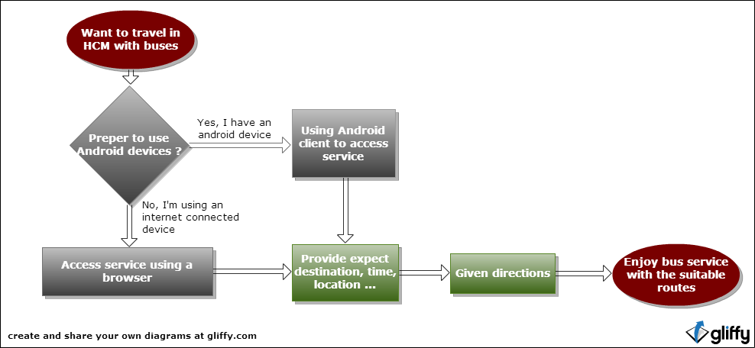

Figure 10: Public User Main Flow

### Staff

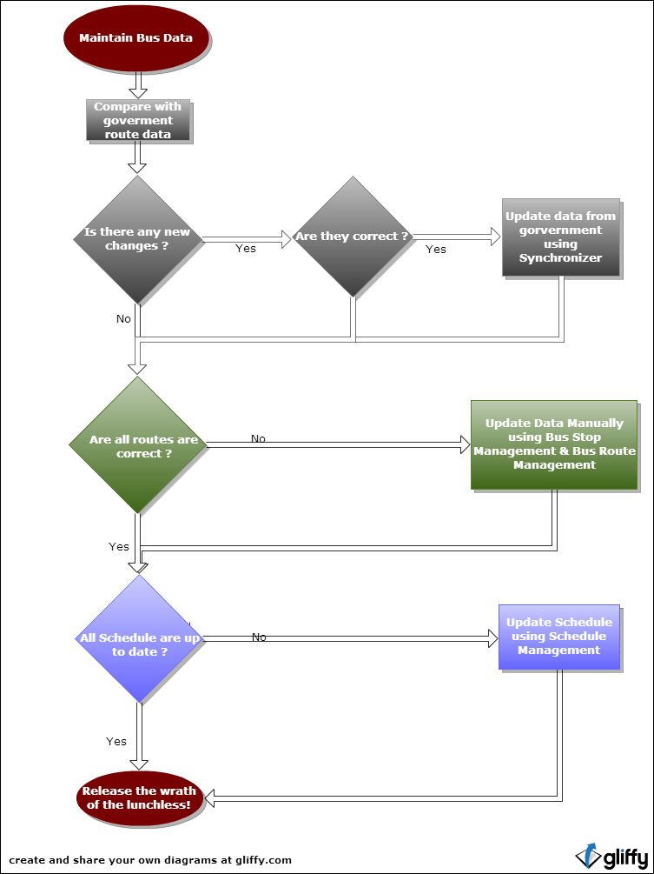

Figure 11: Staff Main Flow

## Entity Relationship - Conceptual

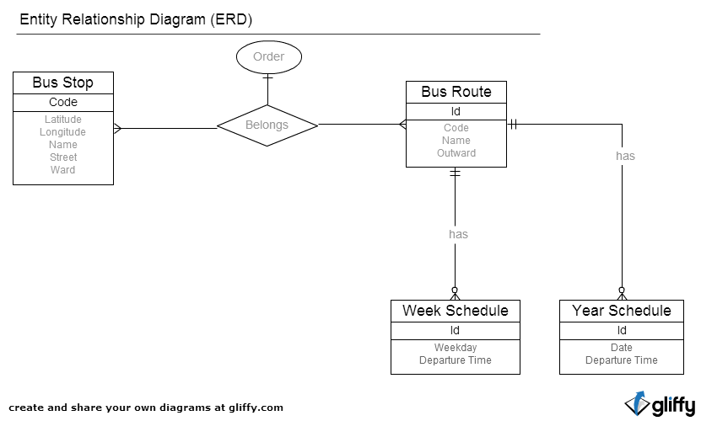

Figure 12: Entity Relationship

1. http://www.nctr.usf.edu/jpt/pdf/JPT12-1Fujii.pdf [↑](#endnote-ref-1)
2. http://www.tinmoi.vn/nam-2012-tphcm-co-370-trieu-luot-nguoi-di-xe-buyt-011153226.html [↑](#endnote-ref-2)
3. http://www.buyttphcm.com.vn/TTLT.aspx [↑](#endnote-ref-3)
4. https://www.assembla.com/spaces/free-private-subversion-repository-only/prepare\_copy?type=private [↑](#endnote-ref-4)
5. https://www.assembla.com/spaces/free-agile-task-management/prepare\_copy?type=private [↑](#endnote-ref-5)
6. http://www.agilekiwi.com/other/agile/definition-of-agile-development/ [↑](#endnote-ref-6)
7. http://msdn.microsoft.com/en-us/library/vstudio/ff926074(v=vs.100).aspx [↑](#endnote-ref-7)